**PHYS 4270 / 5390 4.0 - Astronomical Techniques**

**Fall-Term Project - Part 2/3**

**II. Observing the Open Cluster M34**

**Upload to website by 10 pm, Monday 14 December 2020**

**1 Operating the Telescope and CCD Camera**

1. Introduction:

For this project, you will use the Allan I. Carswell Observatory’s (AICO) [*PlaneWave 1000* reflecting telescope](https://planewave.com/product/pw1000-1-meter-observatory-system/) (Fig. 1) in remote mode to acquire multi-filter photometry of the open cluster, M34[1]. The telescope’s primary mirror has a diameter[2] of 1 metre and a focal ratio of f/6. The telescope is an “alt-az” design, meaning that it tracks celestial objects by moving in altitude and azimuth rather than right ascension (see Chapters 3 and 4).

|  |  |
| --- | --- |
| To prepare to operate the telescope and CCD camera, watch these videos made by the AICO staff:   * A general [tour of the telescope and dome](https://www.youtube.com/watch?v=6DwkXv_Up78&list=PLQG2xolgDEDh-cunZ7uon0T7iDz0QMC2f&index=7) * How to [control the telescope](https://www.youtube.com/watch?v=989yO07Ov84&list=PLQG2xolgDEDh-cunZ7uon0T7iDz0QMC2f&index=4) * How to [control the CCD camera](https://www.youtube.com/watch?v=xBQ-O_Ztazk&list=PLQG2xolgDEDh-cunZ7uon0T7iDz0QMC2f&index=6) * How to [focus the telescope](https://www.youtube.com/watch?v=s8JzhyqVjZM&list=PLQG2xolgDEDh-cunZ7uon0T7iDz0QMC2f&index=5) | https://planewave.com/wp-content/uploads/2019/01/PW1000-2.jpg  Figure 1 – PlaneWave 1000 |

Because of pandemic limitations, observing will take place remotely. This means that the telescope and camera will be controlled from the comfort of your own room, though there will be one or more observatory staff members present on site to ensure safety within the local environment and that the equipment is functioning properly. Consult the Observing Operating Procedures Checklist on the course website that describes systematically how to control the telescope and camera, focus the telescope as well as perform the data acquisition process.

Observing will take place in groups comprised of approximately four students. (Group membership will be decided by the instructor.) All members of a group will take data together remotely (via Zoom), but only one student from each group – the facilitator – will control the telescope and CCD camera via a VNC (Virtual Network Computing) session. (Each group will select its own facilitator.)

Two observing sessions are scheduled for each night: Session I from 7 – 10 pm and Session II from 10 pm – 1 am, all weather permitting. To book a date/session, the facilitator should connect to the link:  <https://teamup.com/ks1acba87c241af5f3> and provide her/his relevant information (e.g., name, email address, and course number, i.e., PHYS 4270 or PHYS 5390). Note that only the facilitator should provide the pertinent data. A group is permitted to reserve a single session. If this session is weathered out or otherwise not useful, the group may then book another (future) session. One session at a time in other words.

Upon booking a Session, the facilitator should send an email to Professor Elaina Hyde ([eahyde@yorku.ca](mailto:eahyde@yorku.ca)) informing her of the booking[3]. Professor Hyde will then will provide authorization to the VNC website from which the facilitator will download the VNC viewer from which the facilitator will control the telescope and camera.

As the session approaches, each group should ensure all members are familiar with the observing videos, have reviewed the observing protocol (see below), have a copy of the Observing Operating Procedures Checklist before them and have already sketched out an observing plan.

* 1. Starting Up:

At the beginning of a Session, the facilitator will communicate via a Zoom session with the on-site observatory staff to ensure the dome, telescope environments are clear, and that start-up may commence. With group support, and referring to the Observing Checklist, the facilitator will, among other things:

* Ensure the telescope power is on
* Open the mirror petals
* Connect to the telescope
* Connect to the CCD camera from SkyX, turn cooling on until things stabilize, and ensure 2×2 on-chip binning is set (see Appendix A-1)
* Focus the Telescope by minimizing the apparent size of a reasonably bright star, preferably in the vicinity of the target (M34)
* Move to the target (M34), confirming the field identity using the finding chart
  1. Observing Sequence:

Refer to Section 2 for the recommended Observing Sequence.

* 1. Shutting Down:

Once the scientific data and recommended calibration data have been acquired, the telescope should be returned to its parked position, and the CCD camera and telescope disconnected. The facilitator will do this in consultation with the on-site staff. (The on-site staff will take and save a sequence of flat fields for each filter used by each group that night and share these data with the relevant group(s).)

* 1. Appendix A-1: The SBIG STXL 6303E CCD Camera

1.5.1 The CCD:

You will be digitally imaging your target using an astronomical-grade CCD camera called the “STXL 6303E”. The CCD chip in the STXL 6303E is made by Kodak (KAF-6303E). It is an array of 3072 × 2048 pixels, each of which is 9 µm × 9 µm in size. The quantum eﬃciency peaks near 85% around 650 nm (i.e., in the *R* filter). The CCD is positioned at the focus of the telescope. While the focal-plane scale is one of the calculations required below, one side of the CCD subtends about 10 arcminutes.

1.5.2 The CCD Camera

The CCD chip itself is housed in a hermetically sealed desiccated chamber beneath a window located at the end of the barrel connecting the camera (see Fig. 2) to the telescope. The entire configuration, including electronics, is referred to as the “camera.” Light from the telescope enters the chamber though a transparent window.

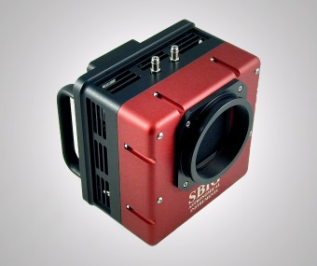

Figure 2: SBIG STXL 6303E CCD Camera

There is an electromechanical shutter in front of the CCD to control the duration of the CCD’s exposure to light. If you take a dark exposure, which is an exposure to quantify the rate of accumulation of charge because of the temperature of the chip, the shutter isn’t physically opened. If you take an exposure of a celestial body, then the shutter is opened for the time you select. Exposure times can be no shorter than 0.12 seconds. In either case, before any signal is acquired, the CCD is cleared automatically of any charge accumulated prior to the initiation of the exposure (such as dark current). To reduce the dark current, the CCD is thermoelectrically cooled down to a temperature about 30-45 (Celsius) degrees below the ambient temperature (thus, the dark current is lower in winter than in summer). A thermostat holds the CCD at a temperature that is constant to ±0.1 C. Consult the relevant video above on how to use the STXL CCD Camera

1.5.3 Filters[4]:

A filter wheel in front of the camera contains three filters, *R, G* and *B* corresponding to *R*, *V*, and *B*. Filters pass light of a particular colour or range of wavelengths. Normally, the choice of filters for a particular project depends upon the astrophysical objectives. However, filtering may also help to reduce the brightness of the night sky relative to celestial bodies, say by excluding emission from city lights (e.g., sodium) or reducing the background contributed by scattered moonlight (which is brightest in the blue). Filters you will need will already be installed in the filter wheel. The filters are “pan focal” meaning that (careful) focussing is only required for a single filter at the beginning of the Session.

1.5.4 Making Sense of an Image:

Making sense of an image from the CCD is sometimes challenging; never more so with an alt-az mounted telescope, a configuration that incurs field rotation. The *PlaneWave 1000* telescope does have an image de-rotator at the Nasmyth port, preserving – at least for shorter exposures – the initial orientation of a field. The (rotated) image in the telescope, however, may be flipped left-to-right, making the field identification challenging (hence the need for a finding chart).

**2 Observational Details**

1. Introduction

The main observational assignment of this course is concerned with obtaining multi-filter CCD photometry of the relatively young and rich open cluster M34 (=NGC 1039) using the *PlaneWave 1000* 1 m telescope. M34 is ideally positioned for fall observing. At a distance of approximately 450 pc, it has a relatively low extinction E(*B*−*V*) = +0.07 mag for a Galactic cluster. Moreover, M34 has a number of stars brighter than *V* = +10, making it an ideal target for our purposes. The data will be reduced using IRAF, a process that is described in a separate handout, the third and final related to the fall-term project.

There is not a great deal of reference material on M34. Perhaps the most-often quoted paper is Jones & Prosser (1996) (a copy of which is on the course website) that discusses a variety of interesting facets of this cluster. More recent research on M34 has concentrated on identifying its white dwarfs and possible associated planets.

The goal of this assignment is to acquire multi-filter CCD photometry for a field centred on M34 using the STXL 6303E CCD. It is not necessary to acquire these data under photometric conditions or to obtain separate standard star exposures. This is because the M34 field itself eﬀectively contains a number of photometric (secondary) standard stars that can be used for this purpose. The plan is to acquire a field in M34 (see the suggestions for a field centre in Appendix A-2) that contains at least three of these photometric standards with which to calibrate your observations, and to compute the apparent magnitudes (and colours) of at least 50 other measurable stars in the field with a *variety of brightnesses*, and then to use this information to study the properties of the cluster itself.

1. General Procedure:

Below, you will find the general observing prescription to be followed. A more detailed discussion of the procedure is contained in Section 4.

1. *Each* *person* must make a 20’ × 20’ finding chart for M34 (an example of which is provided in Appendix A-2, though not with an inverted colour map which is seriously inappropriate!) before booking an observing session. (A finding chart is an essential tool for the observational astronomer at the telescope, particularly with an alt-az telescope. A chart is like a road map; it will be used to confirm that the proper field has been acquired as well as the field orientation.) The J2000.0 position for M34 is:

M34: Right Ascension (α): 2**h**42**m**06**s** Declination (δ): +42◦ 46′

Finding charts should contain the name of the target object and the total angular size of the chart, should have “N” and “E” neatly labeled, and normally should include an arrow indicating the target object, though this is not necessary in this case. The chart should be reproduced with a reasonable contrast. I recommend generating finding charts using the web-based Digitized Sky Survey (DSS) database supported by the Canadian Astronomical Data Centre in Victoria, B.C., whose URL is

<http://www3.cadc-ccda.hia-iha.nrc-cnrc.gc.ca/en/dss/>

From the menu, select “Query by Object Identification.” Enter the Object Name (e.g., M34) and select the RA and Dec box size in decimal arcminutes (e.g., 20.0). Click on “Query DSS by Object Name” and a screen giving “DSS Processing Status” will appear. Every few seconds, click on “Refresh the page.” Eventually, thumbnails of the results are displayed. Select either the “Pal-QV” or the “POSS-II F Red” image and download it. (It is your responsibility to invert the colour map of the DSS image.)

1. Make sure you familiarize yourself with (Galactic) open clusters in general and M34 in particular. The Jones & Prosser paper is a good start. It is always a good idea to know something about your object before observing it.
2. It is imperative that your group becomes familiar with the operation of the telescope and the Observing Checklist before your observing session.
3. Use the STXL 6303E CCD camera during the evening to acquire a set of direct images through the *B, V* and *R* filters centered on one of the recommended field centres (see Appendix A-2) of the open cluster, M34. With appropriate calibration images, these data will be used to study quantitatively the colour-magnitude diagram of the inner part of the cluster, among other things.
4. The data will be processed and analyzed on Cosmos (cosmos.sci.yorku.ca), a linux box, using IRAF in an X-window environment. This aspect of the project will be discussed in more detail in the third and final handout for the fall-term project. (Data will be transferred to cosmos via an sftp connection available from the observatory desktop.)
5. Each person must hand in a typed write-up whose format will be briefly described in Section 4. You will ultimately have to append a fully annotated copy of your observing log and your annotated finding chart to the report.
6. Observing

A separate (detailed) observing log should be kept during the evening. The log, available from the course website, should contain:

* Observers’ names (of your group), Date, weather conditions, CCD temperature and focus position.
* File and Target names, filter, exposure time, EST, UT, ST, RA, Dec and any comments you feel are pertinent (see 2.4.1). (*One member of the group should include the original log, while other members are permitted to include a photocopy*.) Entries for calibration images should contain the EST, the exposure time (where relevant), and any other comments you feel are pertinent.
  + 1. Imaging M34:

One the telescope has been focussed, the CCD camera cooled, and the telescope centred on the appropriate field, you are now ready to begin the scientific observing sequence.

Remember, from this point forward, you must save each exposure to disk in FITS format in the folder generated by your group with a unique name.

[A word about CCD photometry: in order to use the secondary photometric standards provided in Table 1, it is critical that the maximum intensity of a pixel of the brightest of the secondary standards in your particular field be less than 45,000 ADU, the point where non-linearities set in with this camera. The simplest way of ensuring this is to take (for example) a ten-second exposure after the telescope has been focussed and inspect the maximum signal level for the secondary standards in your field. If one or more pixels in your standards exceeds this level, you should decrease the exposure time and redo this procedure. Suppose eight seconds is the (safe) adopted exposure time: then you will need to take a sequence of N, eight-second exposures to achieve the total integration time required for this project (i.e., 4 minutes for *B* and 3 each for *V* and *R*).

There is a photometrist’s trick that might also be of interest here. One of the scientific goals is to generate HR- and colour-colour diagrams of your field in M34. You are required to include a variety of bright, moderate and faint stars in the analysis. In this case, some photometrists will take a number of (for example) eight-second exposures to ensure the secondary standards are safely acquired, followed by a number of (say) 20-second exposures. Why would they do this? Will not the photometric standards be saturated or at least non-linear and therefore unusable in the longer exposures? Yes. However, the photometric zero points can still be calculated from the short exposures and the solution applied to the moderate-and-faint stars in the longer exposures. You do not have to take as many long exposures this way. Think this through carefully before you adopt this latter approach, however.]

A recommended sequence to follow is:

* A sequence of 11 Bias images (filter independent)
* Insert the *R* filter
* Take one 10s *R* image; if the brightest pixel of the brightest standard star is > 45,000 ADU, reduce the exposure time by 2s and try again until the brightest pixel is < 45,000 ADU
* Take a sequence of *R* images so that the total exposure time is 180 s
* When complete, take a series of 5 dark images of the same duration as the *R* images
* Insert the *G* (*V*) filter
* Take one 10s *G* image. If the brightest pixel in the brightest standard star is > 45,000 ADU, reduce the exposure time by 2s and try again until the brightest pixel is < 45,000 ADU
* Take a sequence of these *G* images so that the total exposure time is 180 s
* When complete, take a series of 5 dark images of the same duration as the *G* images
* Insert the *B* filter
* Take one 15s *B* image. If the brightest pixel in the brightest standard star is > 45,000 ADU, reduce the exposure time by 2s and try again until the brightest pixel is < 45,000 ADU
* Take a sequence of these *B* images so that the total exposure time is 240 s
* When complete, take a series of 5 dark images of the same duration as the *B* images
* Take a series of 11 Bias images (filter independent)

[The Flat-field data will be acquired by the on-site observatory staff.]

Refer to the relevant video for instructions on how to close and park the telescope.

* + 1. Downloading Data to Cosmos:

With the scientific and calibration data acquired as FITS files, transfer the data to cosmos (cosmos.sci.yorku.ca) using the “sftp” link.

1. Data Reduction and Write-Up:

An explicit description of the steps involved in data reduction will be provided in the third and final handout. Your primary concern should be acquiring the most complete and best-quality data set at this point.

The data will be reduced and analyzed using IRAF similar to the fall-term CCD assignment using data provided by the instructor. The analysis will require the calculation of instrumental magnitudes (from a curve of growth and aperture correction treatment), the calculation of photometric constants and so the apparent magnitudes of at least 50 stars (apart from the standards) over a range in brightness, the focal-plane scale, orientation/tilt of the image, etc.

The data will be used to plot an HR and Colour-Colour Diagrams, which will then be used to learn something about M34 itself.

The results should be presented in a high quality write-up whose details will be provided in the subsequent document.

* + 1. Advice:

A blank observing log may be found on the course website. It is critical to keep a detailed, handwritten log of the observations. You should specify

* the name of the group/observers, sky/weather conditions, temperature and the unique name of the source, as well as the focus position.

In addition, for each saved exposure (where appropriate):

* the RA, Declination (Hour Angle),
* the (UT and ST) at the starting time of the exposure,
* the exposure duration,
* the filter used,
* the name you assign the data frame when storing it on the hard disk.

References

Jones, B.F., & Prosser, C.F. 1996. Astronomical Journal, 111, pp 1193-1204.

(NB: The PDF of this paper can be found on the class website.)

**APPENDIX A-1: Finding Chart and Photometry for M34**

Figure 3 displays a 20’ × 20’ finding chart of M34 with N up and E to the left and with the photometric (secondary) standard stars indicated. Positions are J2000.0.

|  |  |  |  |  |  |  |
| --- | --- | --- | --- | --- | --- | --- |
|  | Table 1: Data for Photometric Standards in M34 | | | | |  |
| Star | | RA (J2000) | Dec (J2000) |  |  |  |
| ID | Designation | 2**h** 42m+ | +42◦ + | *V* | *B* – *V* | *V* – *R* |
| A | BD+42 597 | 14.4 | 51:59 | +9.34 | −0.01 | +0.01 |
| B | BD+42 593 | 10.6 | 49:56 | +9.64 | +1.08 | +0.66 |
| C | BD+42 594 | 12.1 | 47:11 | +10.05 | +0.00 | +0.00 |
| D | BD+42 596 | 13.5 | 46:41 | +8.73 | +0.07 | +0.04 |
| E | BD+42 601 | 22.1 | 45:37 | +8.78 | +0.03 | +0.01 |
| F | BD+42 602 | 27.3 | 45:29 | +9.35 | +0.01 | +0.00 |
| G | BD+42 595 | 13.0 | 44:50 | +9.96 | −0.01 | −0.01 |
| H | BD+42 590 | 01.8 | 44:54 | +9.65 | +0.16 | +0.09 |
|  |  |  |  |  |  |  |

**APPENDIX A-2: Finding Chart and Photometry for M34**

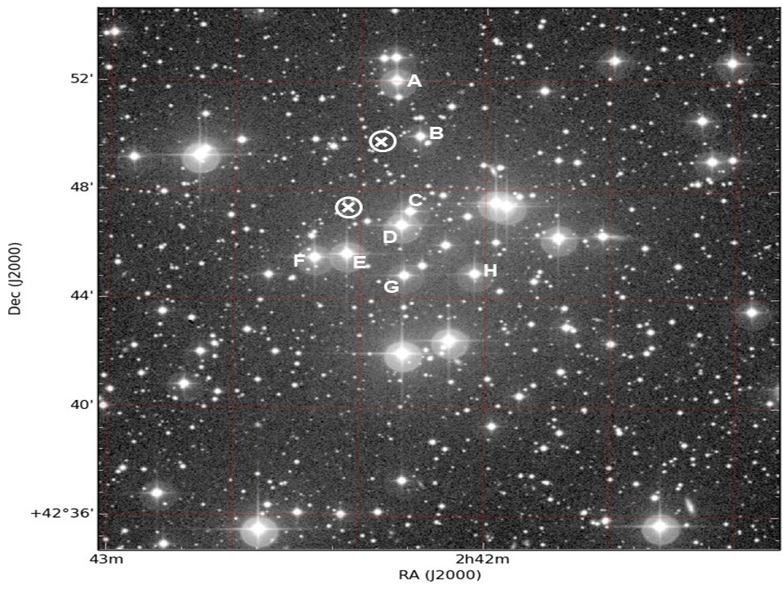



Figure 3: M34 Secondary Standard Star IDs

NB: One of the two positions marked with an “X” circumscribed by a “O” is a suggested field centre for the M34 exposures.

1. Data reduction and interpretation, including the generation of HR- and Colour-Colour Diagrams will be described in the Part 3 of the Fall-Term Project.
2. This is the largest telescope operating on any university or college campus in Canada.
3. Do not leave this to the last minute.
4. SDSS filters were used in part 1 of the fall-term project. Here, Johnson filters are used. The data reduction and calibration methodologies are the same, however.